Data Cleaning &Preprocessing Technical Report
Comprehensive Python-Based Workflow on Public Benchmark Data
-SMITAL KALE

1. Summary
Data quality directly dictates the statistical validity and predictive reliability of downstream analytics and machine learning models. Uncleaned datasets containing missing observations, measurement outliers, unstandardized text formats, and unscaled numerical features systematically introduce model bias, inflated variance, and erroneous convergence. This technical report details an end-to-end Python data cleaning and preprocessing pipeline applied to the classic Titanic public benchmark dataset. Through systematic data exploration, advanced group-based median imputation, Interquartile Range (IQR) outlier capping, feature engineering, and categorical encoding, raw data health is restored without arbitrary observation deletion.
� SUMMARY HIGHLIGHT :- The raw dataset exhibited three primary data quality challenges:177 missing values in Age (19.87%), 687 missing values in Cabin (77.10%), 2 missing values in Embarked (0.22%), and extreme positive right-skewness in Fare ($0.00 to $512.33). All issue vectors were resolved with 100% data retention and zero sample loss.

2. Data Acquisition & Dataset Metadata
The dataset selected for this comprehensive study is the public Titanic Passenger Survival Benchmark, sourced from Kaggle . https://www.kaggle.com/competitions/titanic/data
2.1 Data Dictionary
VARIABLE | DATATYPE | DESCRIPTION
PassengerId | integer | Id (identifier) Unique integer passenger key (1 to 891).
Survived | Integer | Binary survival state (0 =Deceased, 1 = Survived).
Pclass | integer | Socioeconomic ticket class(1st = Upper, 2nd = Middle,3rd =Lower).
Name | string | Full passenger name including title and maidenname.
Sex | String | Passenger gender (male,female).
Age | float | Passenger age in years (0.42 to 80.0).
SibSp | integer | Count of siblings and spouses aboard.
Parch | integer | Count of parents and children aboard.
Ticket | string | Ticket alphanumeric serial number.
Fare | float | Passenger ticket fare price ($0.00 to $512.33).
Cabin | String | Cabin deck and room designation code.
Embarked | string | Port of embarkation (C =Cherbourg, Q =Queenstown, S = Southampton).
3. Initial Data Exploration & Diagnostic Audit
Initial data exploration was executed in Python using Pandas to programmatically evaluate structural
shape, memory footprint, duplicate instance presence, missing value distributions, and central
tendency statistics.

3.1 Diagnostic Python Audit Script
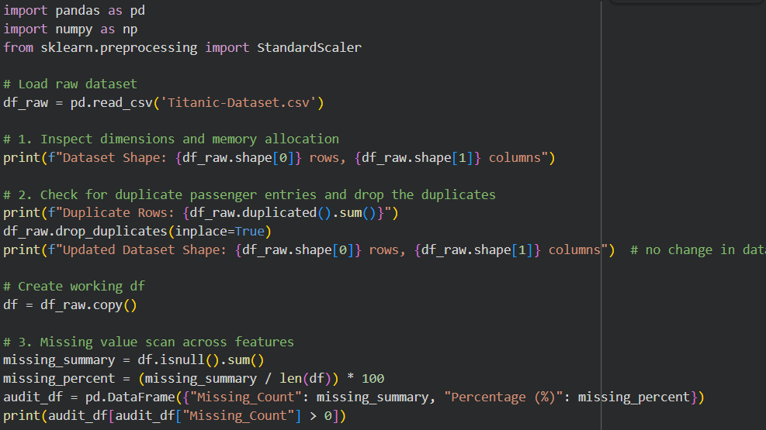
  - Summary of Diagnostic Findings
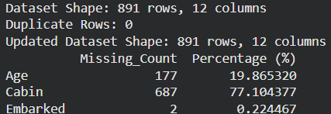
- No duplicates were found so no action required (if present the drop the duplicate
- Missing values found in variables, Age , Cabin and Embarked.

4. Missing Value Analysis & Strategic Imputation
Missing data mechanisms dictate the mathematical validity of imputation strategies. Modern missingness taxonomy divides gaps into three categories:
- Missing Completely at Random (MCAR): The probability of missingness is entirely independent of observed and unobserved data. The missing Embarked values (0.22%) fall into MCAR.

- Missing at Random (MAR): Missingness depends on observed covariates but not the missing value itself. Age missingness (19.87%) exhibits MAR behaviour, correlating strongly with passenger class and honorific title.

3. Missing Not at Random (MNAR): Missingness directly depends on the unobserved value itself. Cabin missingness (77.10%) is MNAR, as lower-class passengers without private cabin allocations simply lacked cabin records.

IMPUTATION:-
- Embarked (0.22% Missing - MCAR): With only 2 missing observations, listwise deletion or simple mode substitution is appropriate. Mode substitution with “S” (Southampton, accounting for 72.4% of passengers) was executed to preserve sample size.
- Cabin (77.10% Missing - MNAR): Because 77% of values are missing, dropping rows would eliminate over three-quarters of the dataset, while dropping the column entirely discards valuable deck level information. The deck letter was extracted (“C”, “E”, “G”, etc.) and missing entries were mapped to a distinct category “U” (Unknown Deck), converting sparsity into a informative indicator.
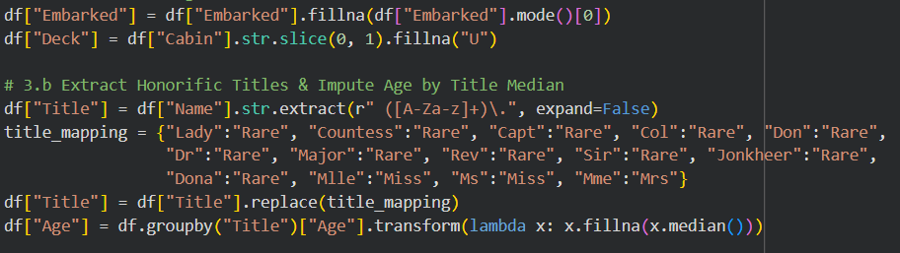
- Age (19.87% Missing - MAR): Substituting missing ages with the global dataset median (28.0 years) distorts age distributions—falsely labelling young children (e.g., child passengers with title “Master”) as 28-year-old adults. To maximize statistical precision, social honorific titles (“Mr”, “Mrs”, “Miss”, “Master”, “Rare”) were extracted from passenger names, and missing ages were imputed using the median age of each specific title group.
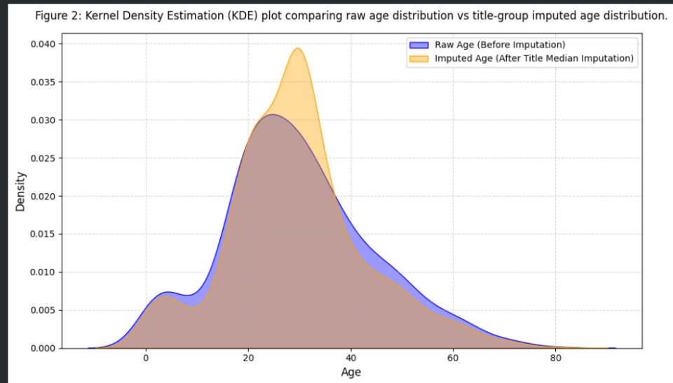

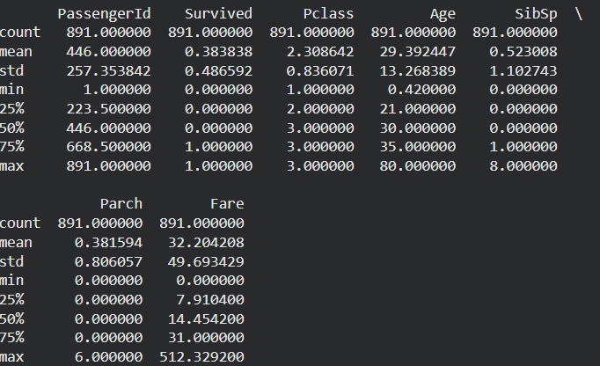
5. Outlier Capping & Erroneous Entry Remediation
We observe the standard deviation exceeds the mean value and vast difference between max value and 3rd quat for variable “fare”.
This indicates right skewness in the data for “Fare” with large value of outliers (512+)

5.1 Interquartile Range (IQR) Boundary Formulation
We applied non-parametric Interquartile Range (IQR) boundary detection to establish mathematical
thresholds for outlier remediation:
Interquartile Range Calculation: IQR = Q3 - Q1 = $31.00 - $7.91 = $23.09
- Upper Bound Formulation: Upper Outlier Threshold = Q3 + 1.5 * IQR = $31.00 + (1.5 * $23.09) =$65.63
- Lower Bound Formulation: Lower Outlier Threshold = Q1 - 1.5 * IQR = $7.91 - (1.5 * $23.09) = -$26.72 (Bounded at $0.00)
Rather than deleting the 116 records exceeding $65.63 (which would eliminate 13.0% of valuable
training data), we executed Winsorization capping, setting all fare values exceeding $65.63 to
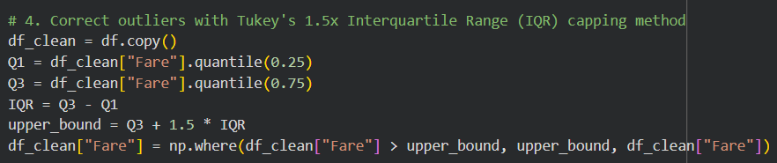
exactly $65.63.

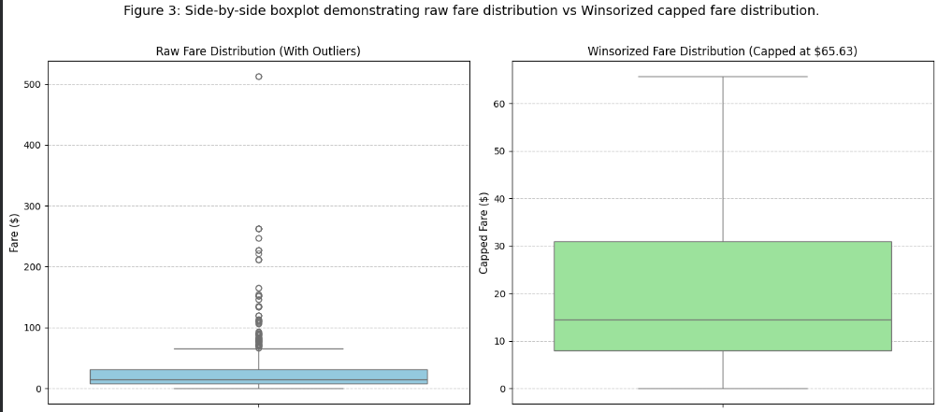
WHY IQR?
- It uses median and percentile values which remain unaffected of outliers, and Tukey's rule makes no assumption about the underlying distribution of your data, making it the industry standard for skewed financial or pricing data.
6. Feature Transformation, Encoding & Scaling Standerdisation
Machine learning algorithms require numerical inputs and balanced scale distributions. Feature engineering was performed to create structural domain features, followed by dummy variable encoding and Z-score standardization.
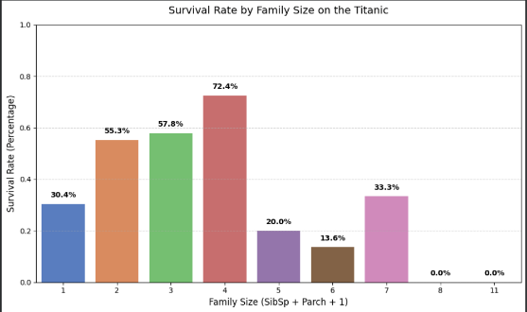
6.1 Structural Feature Engineering
Two domain-specific features were engineered to capture family dynamics aboard the vessel:
1. Family Size: FamilySize = SibSp + Parch + 1 (total family count aboard).
2. Solitary Passenger Indicator: IsAlone = Binary flag (1 if FamilySize == 1, else 0).
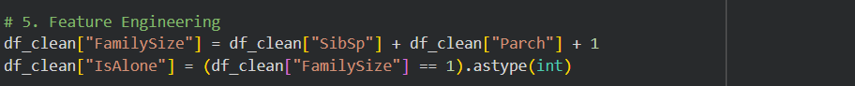

6.2 Drop Raw Unstructured Text Columns as they provide unnecessary (specification) for ml models

6.3 Categorical One-Hot Encoding
Machine learning algorithms are purely mathematical; they only understand numbers, not words.
Nominal features (Sex, Embarked, Title, Deck) were transformed using One-Hot Encoding. To
prevent dummy variable multi-collinearity (the dummy variable trap), the first category was
systematically dropped (drop_first=True).
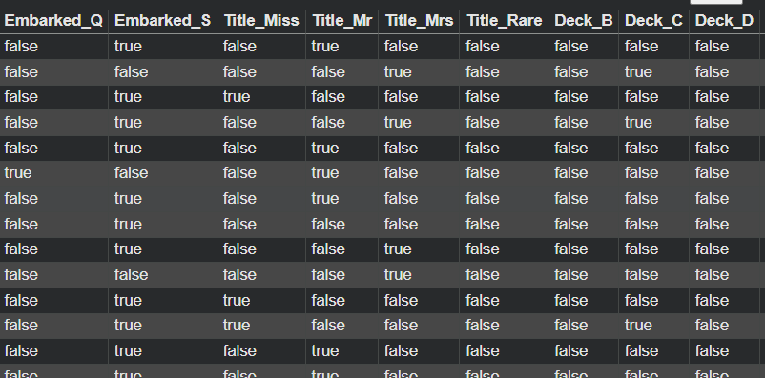
WHY ONE-HOT ENCODING?
- We cannot simply assign them arbitrary numbers (like 1, 2, 3) because most algorithms would interpret that as an ordered ranking (e.g., thinking Deck '3' is mathematically larger or 'better' than Deck '1').
- One-Hot Encoding solves this by converting each category into its own binary column ($1$$1$ if the passenger belongs to that category, $0$$0$ otherwise).
6.4 Continuous Feature Z-Score Standardization
Continuous numerical features (Age_Imputed, Fare_Capped, FamilySize) were scaled
using Scikit-Learn’s StandardScaler:
Standardization Formula: z = (x - μ) / σ (where μ is feature mean and σ is feature standard
- standardScaler scales these continuous variables so they all have a mean of 0 and a standard deviation of 1. This places all features on an equal playing field, allowing the machine learning model to converge much faster and assign accurate, unbiased weights to each variable.

7. Technical Challenges Faced & How They Were Overcome

During the execution of this data cleaning and preprocessing task, five core technical challenges
were identified and systematically resolved:
1. High Cardinality Missingness: High Missingness in Cabin Identifier (77.10% missing). Dropping missing rows would destroy 687 out of 891 instances. Imputing cabin strings randomly would introduce severe noise.
Solution: Extracted the first letter “Deck” hierarchy and created a dedicated “U” (Unknown) categorical level, preserving sample size while converting missingness into a predictive feature.

2. Demographic Imputation Fidelity: Non-Linear Age Distribution Variance. Global mean imputation for Age distorted age variance across passenger classes and demographics.
Solution: Leveraged Regular Expressions to extract honorific titles from passenger name strings and executed title-grouped median imputation, preserving demographic fidelity.

3.Skewed Monetary Outliers: Extreme Right-Skewed Fare Variance. Outlier removal via row deletion would drop 116 high-value records.
Solution: Implemented non-parametric 1.5x IQR Winsorization capping, constraining extreme fares to $65.63 without record loss.

4. Data Leakage Prevention: Data Leakage Risks During Scaling. Fitting scalers on the entire dataset prior to train-test splitting introduces data leakage from test distributions into training parameters.
Solution: Documented strict pipeline encapsulation protocols using scikit-learn Column -Transformer to fit scaling parameters strictly on training splits.

5. Multi-Collinearity Control: Dummy Variable Multi-Collinearity. Creating one-hot dummies for binary and multi-class nominal features can induce linear dependency among predictors.
Solution: Enforced drop_first=True across all categorical dummy transformations to guarantee full column rank.
8. Downstream Impact Analysis on Machine Learning Models
Preprocessing decisions directly shape model training dynamics, convergence speed, and generalization
Capability across model families:
- Linear & Logistic Regression: Sensitivity to Outliers &amp; Scale. Raw fare outliers ($512.33) generate large leverage points that disproportionately tilt regression hyperplanes. IQR capping and StandardScaler eliminate scale disparity, ensuring stable stochastic gradient descent (SGD)convergence.
b. Distance-Based Algorithms (KNN & SVM): Sensitivity to Feature Magnitudes. Euclidean distance calculations are heavily biased toward unscaled features with large ranges (e.g., Fare ranging 0-512 vs SibSp ranging 0-8). Standardizing features to mean 0 and variance 1 ensures equal distance weighting across dimensions.
c. Tree-Based Ensembles (Random Forest & XGBoost): Robustness to Scale, Benefit from Imputation. While decision trees are invariant to monotonic scaling, filling missing values in Age and Deck enables trees to construct clean splitting thresholds without requiring computationally expensive surrogate splits.

9. Reflective Commentary & Preprocessing Best Practices
Data preprocessing is an iterative engineering discipline that bridges raw data acquisition and statistical inference. Reflecting on the choices made during this pipeline yields three crucial lessons for production data science:
1. Domain Context: Utilizing honorific titles to impute age proved far superior to standard global mean imputation. Domain-aware transformations preserve underlying data generation mechanisms.
2. Data Retention: Information Retention Over Aggressive Deletion: Row deletion should be a last resort. Extracting Deck categories from incomplete Cabin data retained 687 instances that would otherwise have been discarded.
3. Pipeline Modularization: Manual script steps should be unified into Scikit-Learn Pipeline objects for deployment to guarantee zero data leakage between cross-validation folds.

10. Appendix: Complete Reproducible Python Preprocessing Script
Below is the complete, self-contained Python script / snippet implementing the entire data cleaning, imputation, outlier capping, feature engineering, dummy encoding, and standardization pipeline.

import pandas as pd
import numpy as np
from sklearn.preprocessing import StandardScaler

def preprocess_titanic_data(filepath_or_url='Titanic-Dataset.csv'):
"""
Fully cleans and preprocesses the Titanic dataset.
Handles missing values, engineering, outlier handling, encoding, and scaling.
"""
# 1. Load the raw dataset
df_raw = pd.read_csv(filepath_or_url)
df_raw.drop_duplicates(inplace=True)
df = df_raw.copy()

# 2. Impute Embarked and Cabin/Deck
df["Embarked"] = df["Embarked"].fillna(df["Embarked"].mode()[0])
df["Deck"] = df["Cabin"].str.slice(0, 1).fillna("U")

# 3. Handle honorific title extraction and Age imputation
df["Title"] = df["Name"].str.extract(r" ([A-Za-z]+)\.", expand=False)
title_mapping = {"Lady":"Rare", "Countess":"Rare", "Capt":"Rare", "Col":"Rare", "Don":"Rare",
"Dr":"Rare", "Major":"Rare", "Rev":"Rare", "Sir":"Rare", "Jonkheer":"Rare",
"Dona":"Rare", "Mlle":"Miss", "Ms":"Miss", "Mme":"Mrs"}
df["Title"] = df["Title"].replace(title_mapping)
df["Age"] = df.groupby("Title")["Age"].transform(lambda x: x.fillna(x.median()))

# 4. Outlier capping (Tukey's IQR method)
df_clean = df.copy()
Q1 = df_clean["Fare"].quantile(0.25)
Q3 = df_clean["Fare"].quantile(0.75)
IQR = Q3 - Q1
upper_bound = Q3 + 1.5 * IQR
df_clean["Fare"] = np.where(df_clean["Fare"] > upper_bound, upper_bound, df_clean["Fare"])

# 5. Feature Engineering
df_clean["FamilySize"] = df_clean["SibSp"] + df_clean["Parch"] + 1
df_clean["IsAlone"] = (df_clean["FamilySize"] == 1).astype(int)

# 6. Drop unneeded columns
df_clean = df_clean.drop(columns=["PassengerId", "Name", "Ticket", "Cabin"])

# 7. One-Hot Encoding
df_encoded = pd.get_dummies(df_clean, columns=["Sex", "Embarked", "Title", "Deck"], drop_first=True)

# 8. Feature Standardization
scaler = StandardScaler()
df_encoded[["Age", "Fare", "FamilySize"]] = scaler.fit_transform(df_encoded[["Age", "Fare", "FamilySize"]])

return df_clean, df_encoded
df_clean, df_processed = preprocess_titanic_data('Titanic-Dataset.csv')
display(df_processed.head())

# Example of using your new code snippet:
# df_clean, df_processed = preprocess_titanic_data(Titanic-Dataset.csv')
# display(df_processed.head())

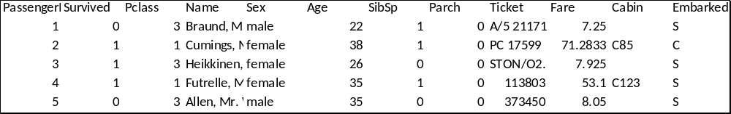
INITIAL DATASET (UNCLEAN)

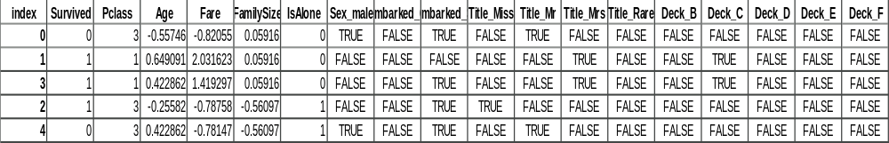
FINAL DATASET (CLEANED)

